Importing a Python Module

This document guides you through importing a given module in Python and importing a standard module from the Python Library.
You are to attempt Part A and B using Visual Studio Code, and Part C using Jupyter Notebook.
Pre-requisites:
- Complete the pre-class material on Functions
- Download and unzip the ‘Importing module.zip’ from eLearn.
Part A – Importing a Given Module

As your program gets longer, you may want to split it into several files or modules for easier maintenance and code readability. A module can then be imported into other modules or into the main module.
- Launch Visual Studio Code (VS Code)

- Select File -> Open Folder from the menu in VS Code

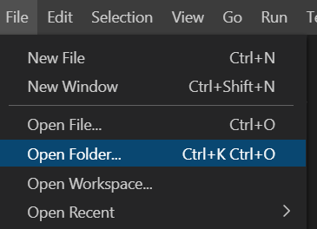

- Select the “Importing module” folder that you have downloaded from eLearn and unzipped.

- You should now see the directory being reflected in the Explorer panel in VS Code

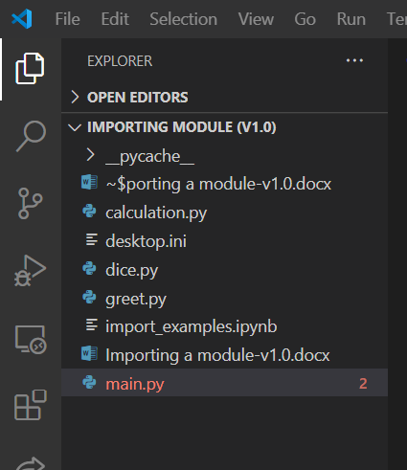
Note: Files with .py extension tells the VS Code interpreter that it is a program file or script written in Python.

- Select the file greet.py in the VS Code explorer panel, you will observe two functions: say_hello and say_bye.

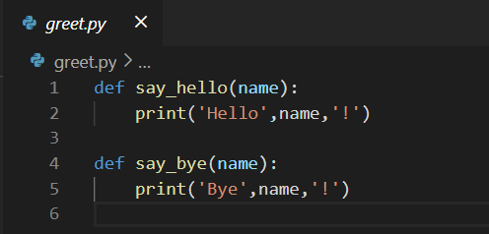

- In the same directory, there is main.py, wanting to make use of these 2 functions written in greet.py.
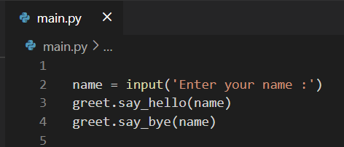
If you run the module main.py and enter the name ‘John’, you will get the following error in your terminal panel:
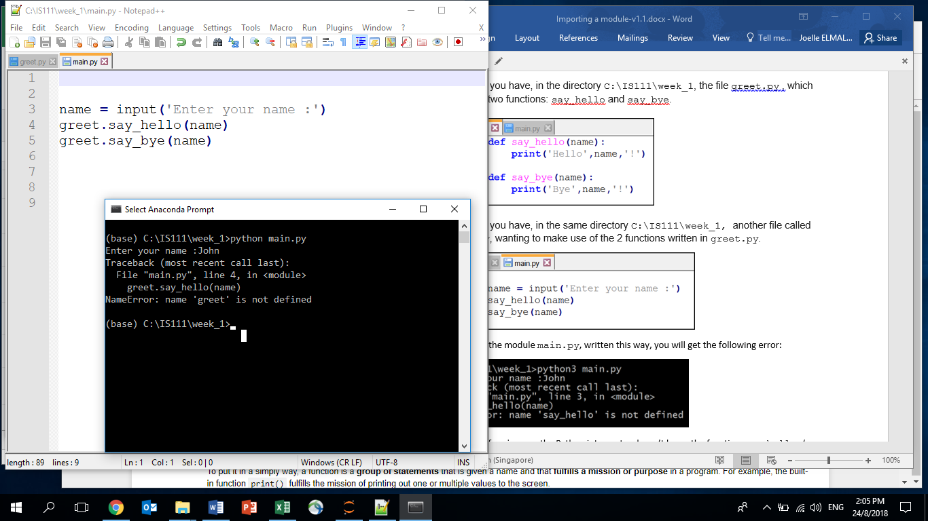
Explanation: At line 4 of main.py, the Python interpreter doesn’t know there is a python file (or module) name greet nor the function say_hello (neither the other function say_bye).
The reason is that they have been defined in the module greet.py. Therefore we need to import the module greet into the main module.
- Add a line of code import greet into the first line of main.py. The code of the main module now becomes:

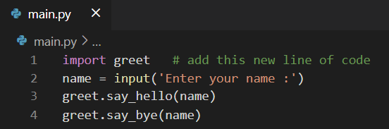
Notice 2 things here:
- In line 1, we have the statement import greet (and NOT import greet.py)
- When we invoke the 2 functions say_hello and say_bye, their names are preceded by “greet.“ .
Notice the dot symbol and the greet prefix: this is to express the fact that the functions are actually defined in the greet module.
When we run main.py again and enter the name ‘John’, we get the following output:
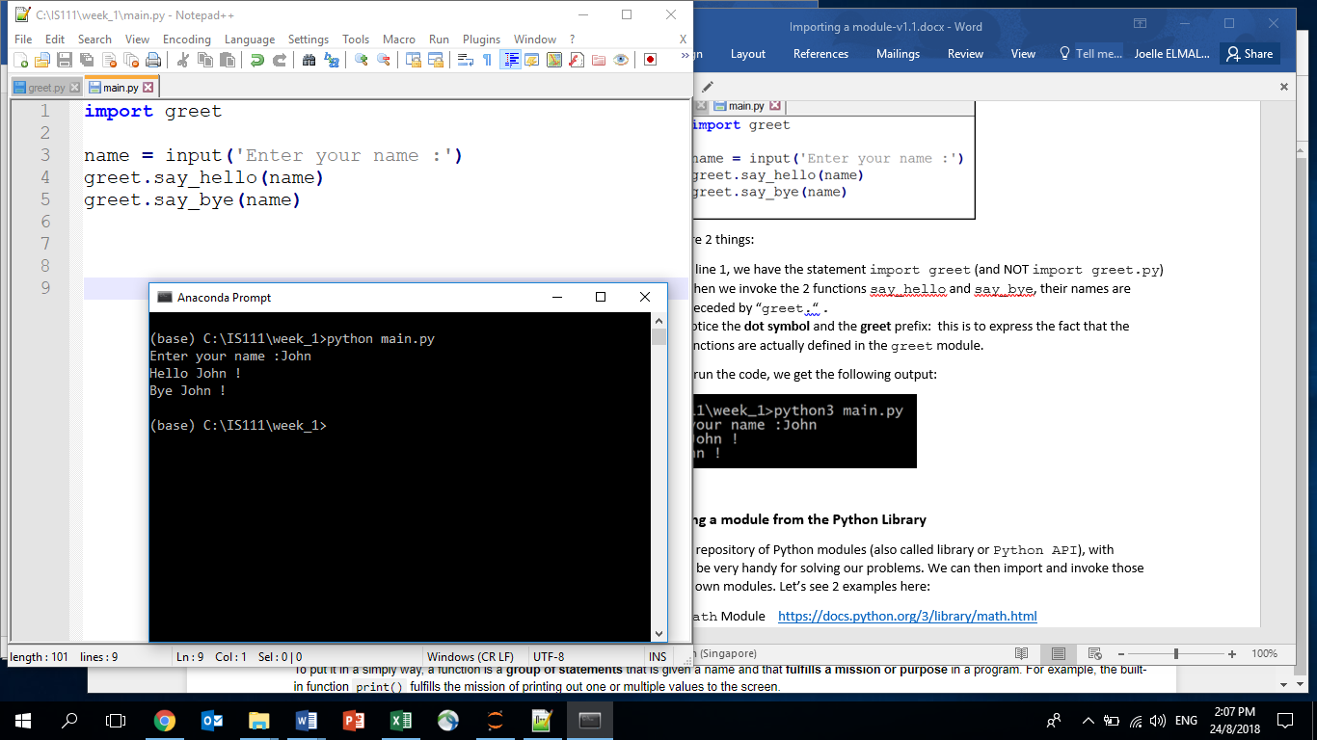

- Let’s now try to write a new function on our own in greet.py and call it from main.py. Go to greet.py and add a new how_are_you function as follows:
def how_are_you(name):
print('How are you,',name,'?')

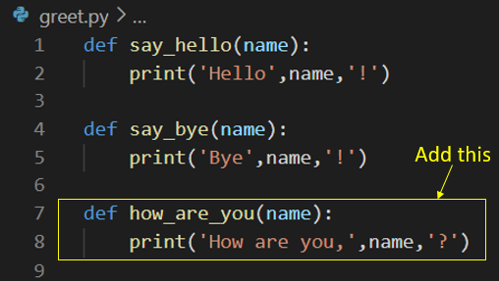
Save the file.
- Go to main.py and add the following code in line 4 to call the how_are_you function that we have just written:
greet.how_are_you(name)

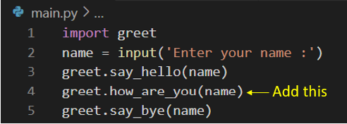
When we run the code, we get the following output:
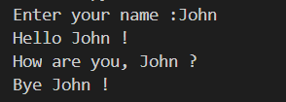
Explanation: import greet allows main.py to access and call the functions in greet.py including the how_are_you() function that we have just added.
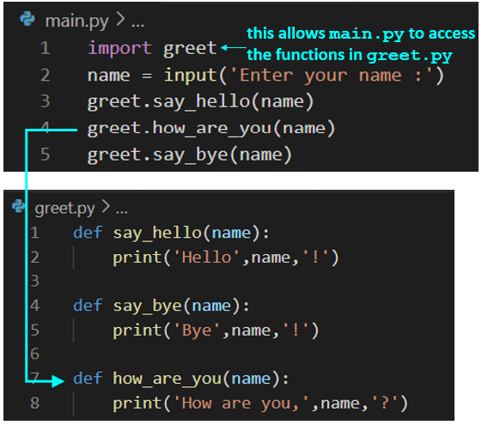

Part B – Importing a module from the Python Library

Python provides a repository of Python modules (also called library or Python API), with standard functions that can be very handy for solving our problems. We can then import and invoke those functions into our own modules.
Let’s see 2 examples here:
Example 1 - The math Module https://docs.python.org/3/library/math.html
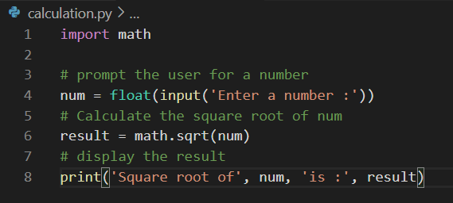
In the calculation.py that can be found in the Importing module folder, we import the math module provided by the Python library in line 1, and we invoke the square root function : sqrt()in line 6, which calculates for us the square root of the number passed in as argument to the function.
When we execute the code, we get the following output:
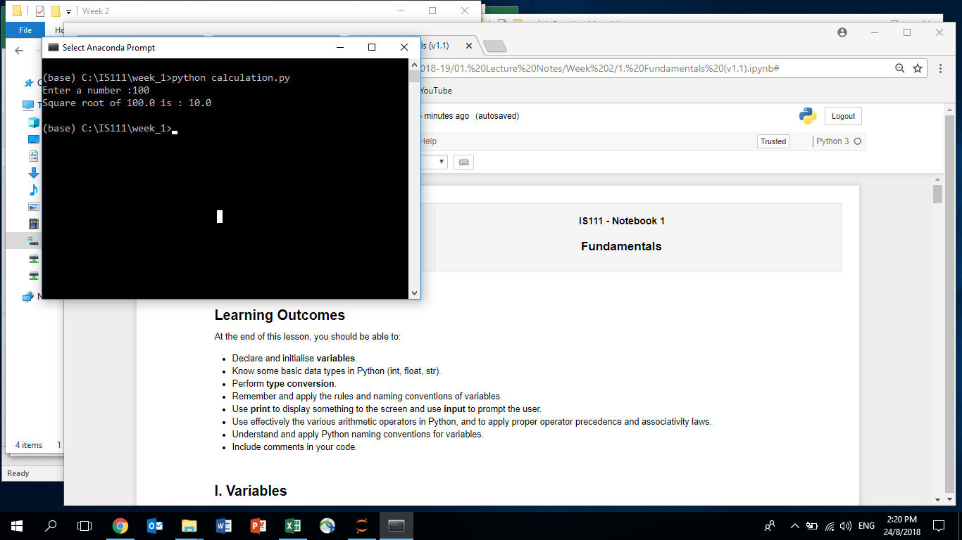

Example 2 - The random Module https://docs.python.org/3/library/random.html
The random module is also a useful module that allows us to generate random numbers easily. Open dice.py that can be found in the Importing module folder and try the example below: 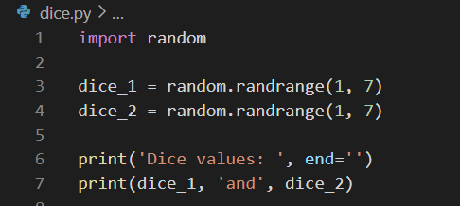
- In line 1, we import the random module provided by the Python library
- In Line 3 and 4, we invoke the randrange function from the random module, to generate two integer random numbers between 1 (inclusive) and 7 (exclusive). In other words, the random number generated by randrange(1, 7) can be 1, 2, 3, 4, 5 or 6.
Notice again that the function randrange needs to be preceded by “random.” (do not forget the dot!) as randrange is a function within the random library.
When we execute the code, we get the following output:
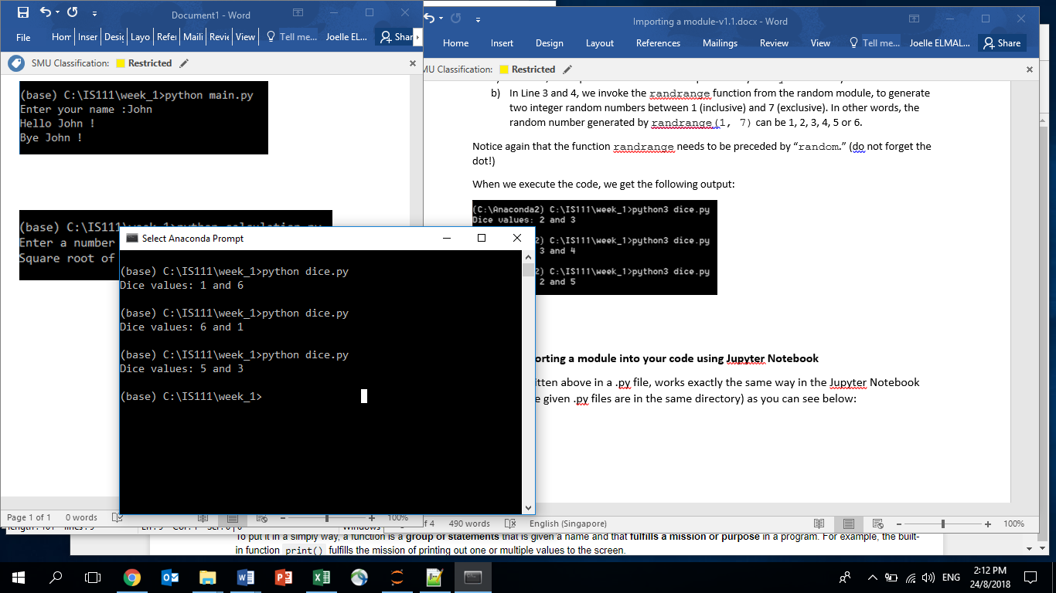

Part C – Importing a module into your code using Jupyter Notebook

Open import_examples.ipynb (found in the same importing module folder).
Run the cells in the import_examples.ipynb.
You will observe that the codes in Jupyter Notebook works exactly the same as the .py files shown in Part A, as long as the given .py files that you wish to import are in the same directory as your Jupyter Notebook file:
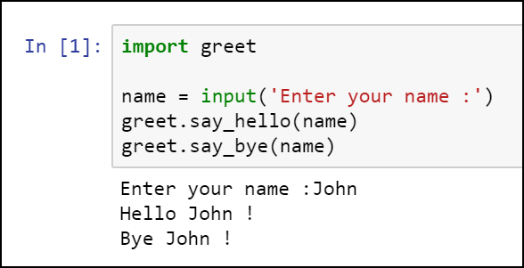
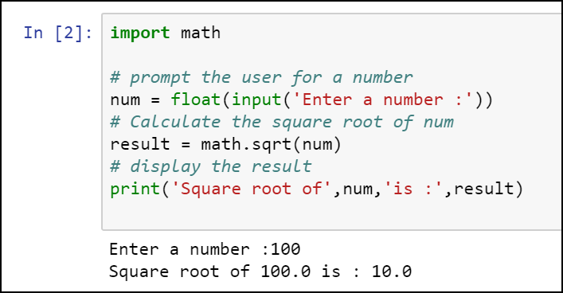

Congratulations! You are now able to import Python modules.

